**File Handling**

Source Code:

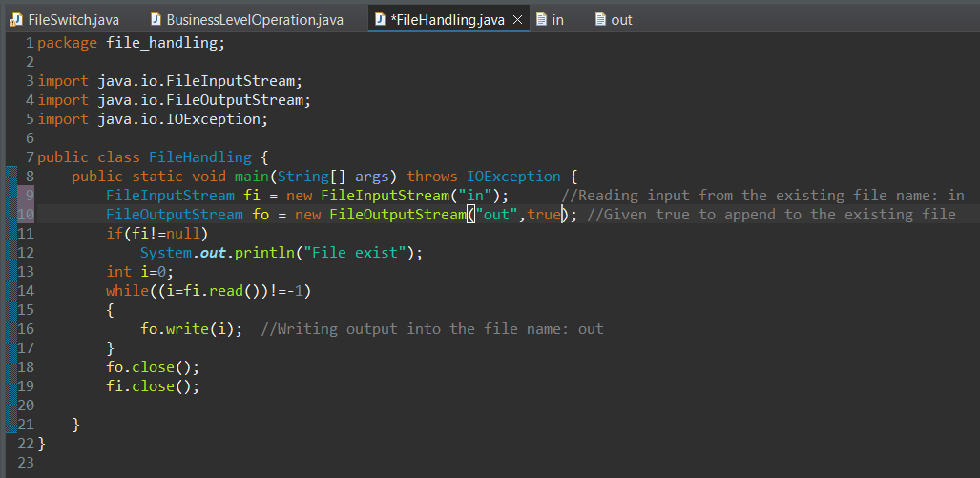

Output:

